
Implementation Manual


Installation Manual
The implementation manual includes the steps to install Google Chrome and Microsoft WebMatrix on the Windows platform. In addition, it includes the steps to add the iPad/iPhone simulator in the Microsoft WebMatrix.

Installing Google Chrome
To install Google Chrome, you need to perform the following steps:
- Open the following link:
- https://www.google.com/intl/en/chrome/browser/?hl=en&brand=CHMA&utm_campaign=en&utm_source=en-IN-ha-bk&utm_medium=ha&utm_term=%2Bchrome%20browser
- Click the Download Chrome button. The Get a fast, free web browser dialog box appears, as shown in the following figure.
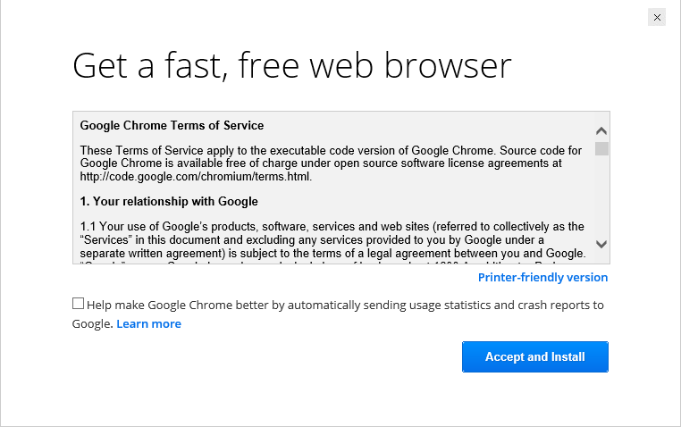
The Get a fast, free web browser Dialog Box
- Click the Accept and Install button. The Launching Application message box appears for a while.

Note

If the User Account Control dialog box appears, you may need to specify your credentials and click the Yes button.

After a few seconds, the Application Run – Security Warning dialog box appears, as shown in the following figure.
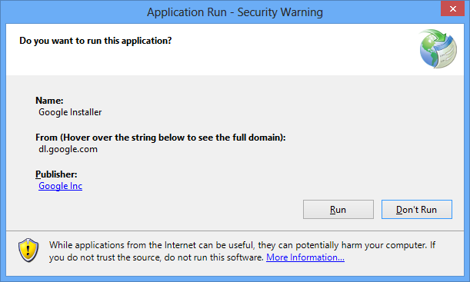
The Application Run – Security Warning Dialog Box
- Click the Run button. The Downloading Google Installer window appears, as shown in the following figure.
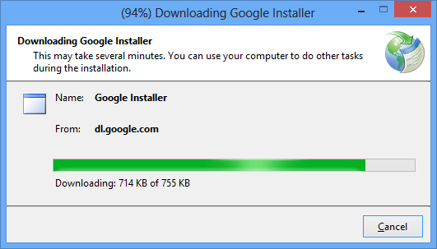
The Downloading Google Installer Window
After a few seconds, the Google Chrome Installer window appears, displaying the progress of the downloading task, as shown in the following figure.
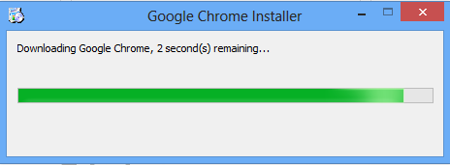
The Google Chrome Installer Window

Note
If the The installer could not connect to the Internet. Ensure that your computer is connected to the Internet and your firewall allows GoogleUpdate.exe to connect then try again. message appears, then ensure that you are connected to the Internet and the firewall is turned off.

The moment download process is complete; the Welcome to Chrome dialog box appears, as shown in the following figure.
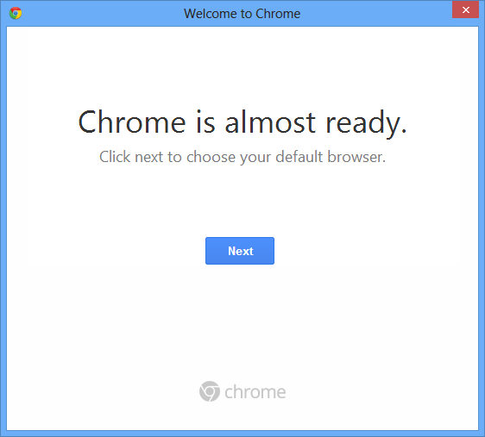
The Welcome to Chrome Dialog Box
- Close the Welcome to Chrome dialog box. The Welcome to Chrome page appears in a Web browser, as shown in the following figure.
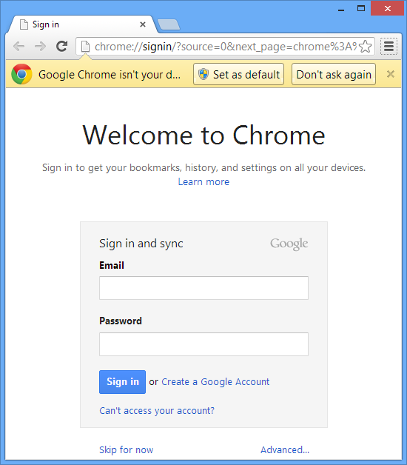
The Welcome to Chrome Page
- Close the Web browser.

Installing Microsoft WebMatrix
To install the Microsoft WebMatrix software, you need to perform the following steps:
- Open any Web browser.
- Type the following URL in the address bar of the Web browser to download the WebMatrixWeb.exe file:
- http://www.microsoft.com/web/webmatrix/

After a few seconds, the WebMatrix3 Web page appears, as shown in the following figure.
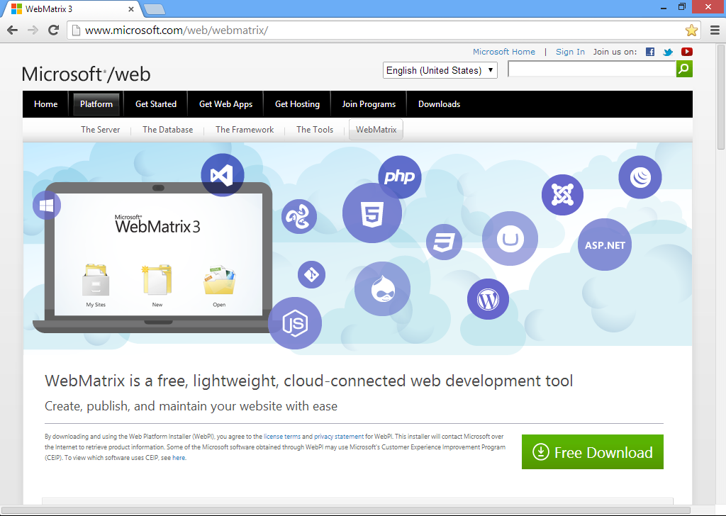
The WebMatrix3 Web page
- Click the Free Download button to download the WebMatrixWeb.exe file. After a few seconds, the WebMatrixWeb.exe file will download to the Downloads folder or other specified location.
- Browse to the location of the WebMatrixWeb.exe file.
- Double-click the WebMatrixWeb.exe file to start the setup. The Web Platform Installer 5.0 wizard appears, as shown in the following figure.
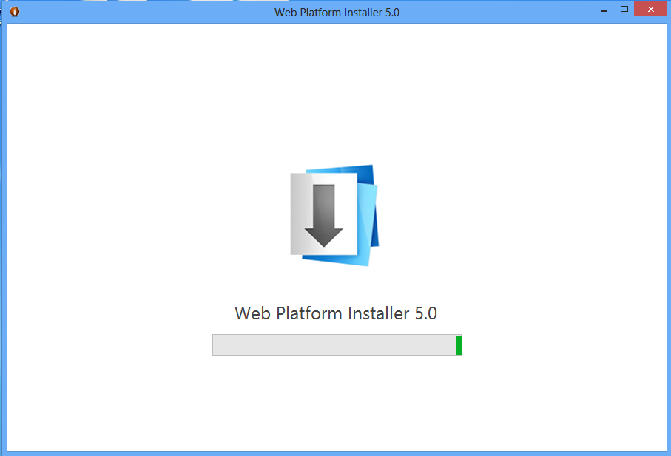
The Web Platform Installer 5.0 Wizard
After a few seconds, the Microsoft WebMatrix3 page of the Web Platform Installer 5.0 wizard appears, as shown in the following figure.
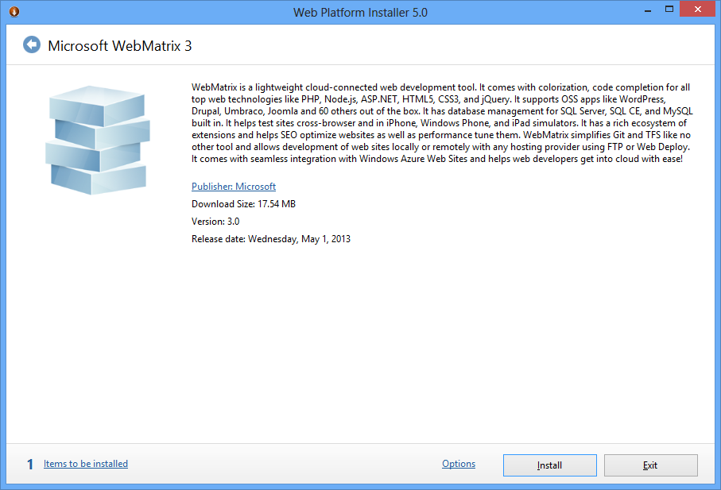
The Web Platform Installer 5.0 Wizard
- Click the Install button. The license page appears, as shown in the following figure.
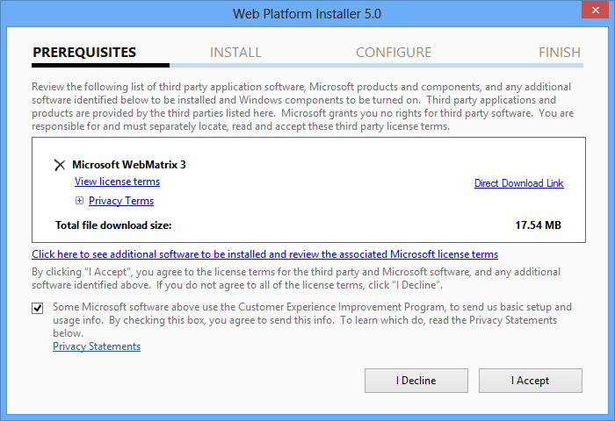
The License Page
- Clear the Some Microsoft software above use the Customer Experience Improvement Program, to send us basic setup and usage info. By checking this box, you agree to send this info. To learn which do, read the Privacy Statements below. check box.
- Click the I Accept button. A progress bar appears, as shown in the following figure.
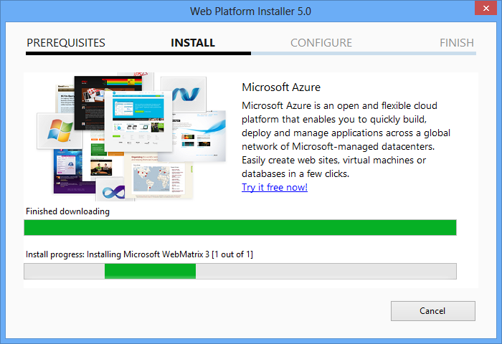
A Progress Bar

After a few seconds, The The following products were successfully installed. message appears, as shown in the following figure.
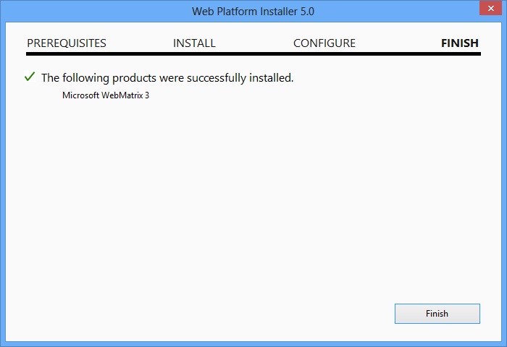
The following products were successfully installed Message
- Click the Finish button. A list of other installation options appears, as shown in the following figure.
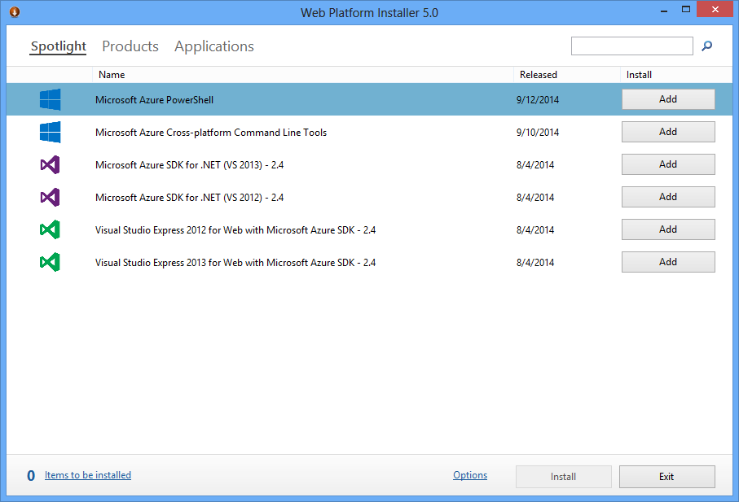
A List of Other Installation Options
- Ignore the other installation options and click the Exit button.

Adding iPad/iPhone Simulator
To add the iPad/iPhone simulator, perform the following steps:
- Press the Windows key.
- Type webmatrix and press the Enter key. The Quick Start – Microsoft WebMatrix window appears, as shown in the following figure.
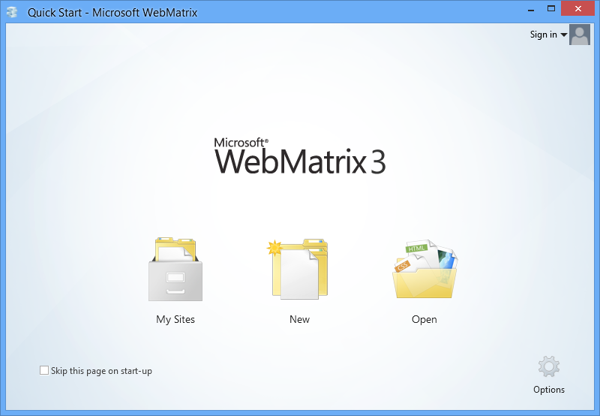
The Quick Start – Microsoft WebMatrix Window
- Click the New button.
- Select the Empty Site option. The EmptySite – Microsoft WebMatrix window appears, as shown in the following figure.
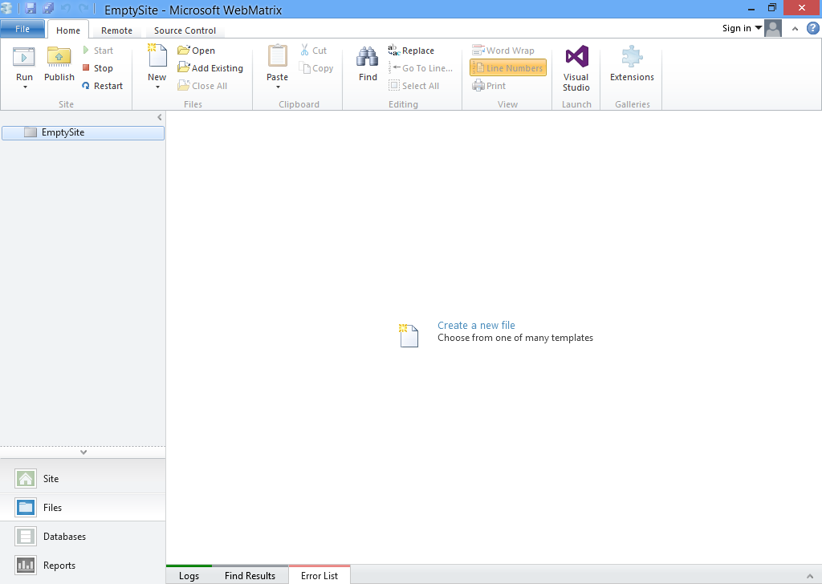
The EmptySite – Microsoft WebMatrix Window
- Click the Run drop-down button. A drop-down list appears, as shown in the following figure.
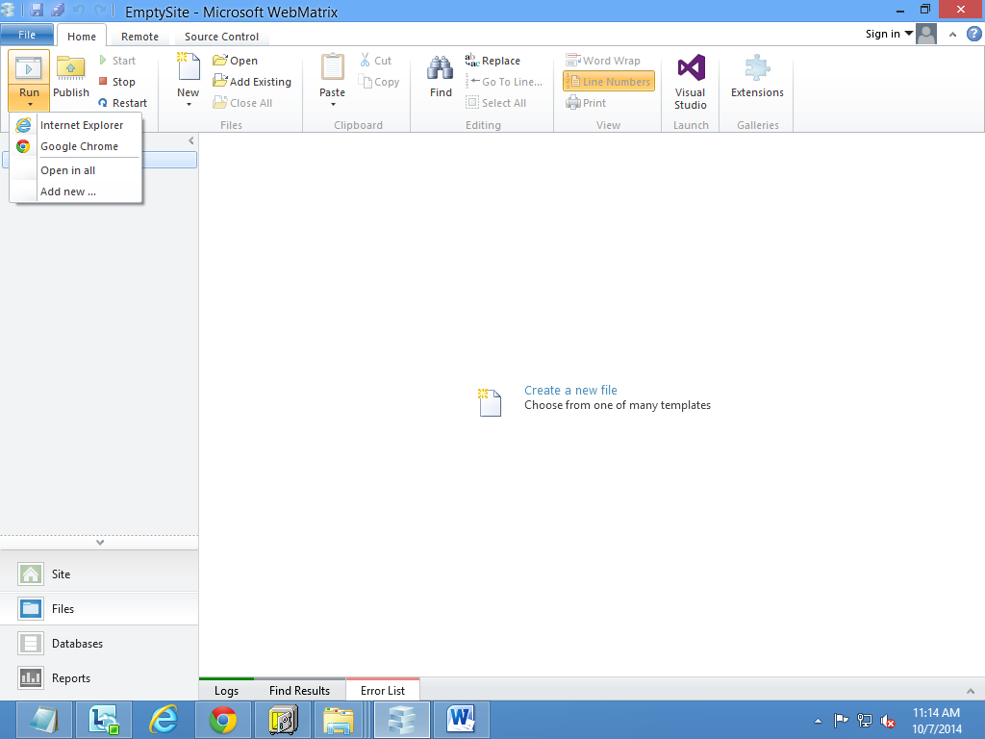
A Run Drop-Down List

- Select the Add new option. The Browser Extension Gallery wizard appears that displays a message, Loading extension gallery. After a few seconds, a list of simulators gets displayed in the Browser Extension Gallery wizard, as shown in the following figure.
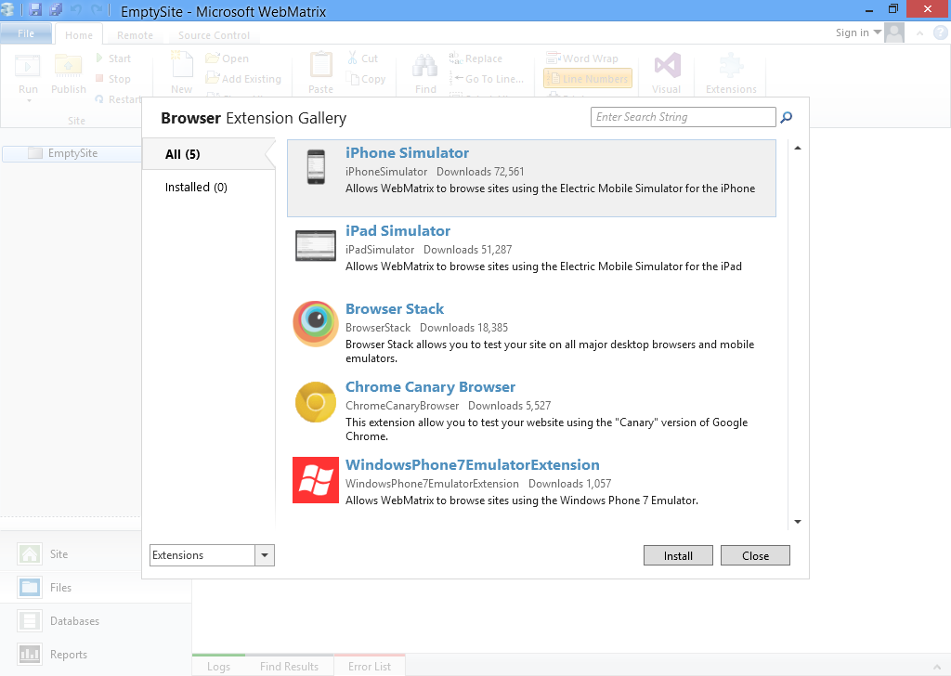
A List of Simulators in the Browser Extension Gallery Wizard
- Ensure that the iPhone Simulator option is selected and click the Install button. The iPhone Simulator page appears, as shown in the following figure.
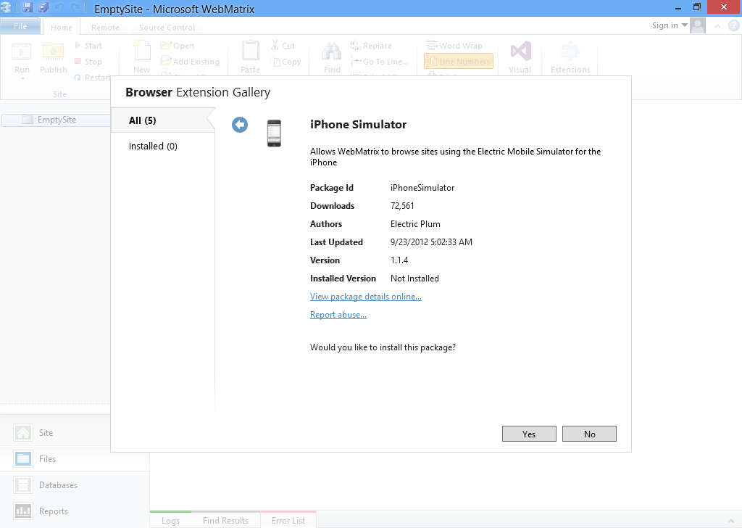
The iPhone Simulator Page
- Click the Yes button. The Accept EULA page appears, as shown in the following figure.
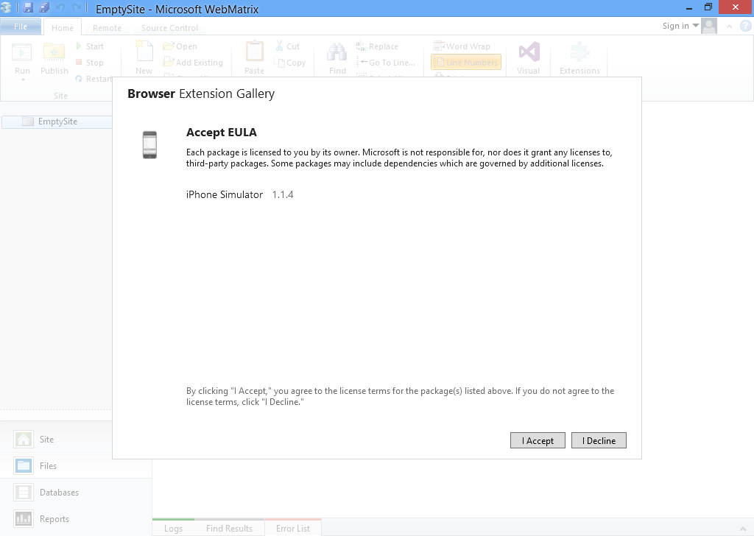
The Accept EULA Page
- Click the I Accept button. The Installing message appears. After a few seconds, the options for simulators appear, as shown in the following figure.
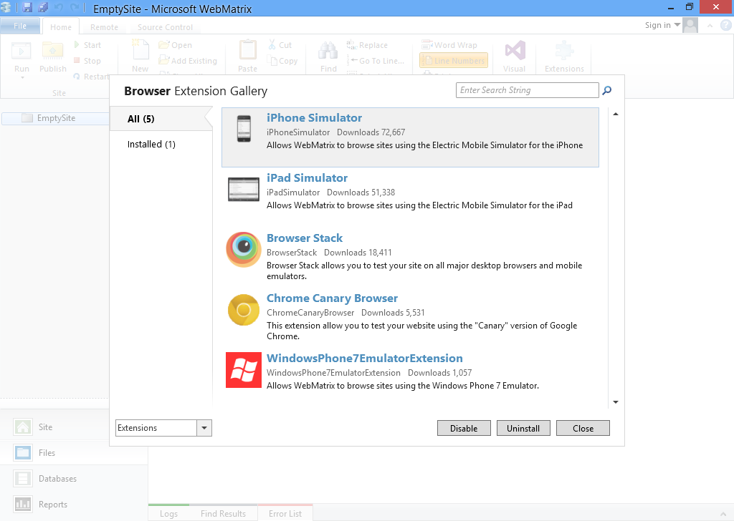
The Options for Simulators
- Click the Close button. The EmptySite – Microsoft WebMatrix window appears, as shown in the following figure.
The EmptySite – Microsoft WebMatrix Window
- Click the Run drop-down button. You will notice that the iPhone simulator option is added in the list. Similarly, you can add the iPad simulator.

